

FACULTY OF ENGINEERING AND TECHNOLOGY
BACHELOR OF TECHNOLOGY

Database Management System Laboratory
(303105204)

3rd Semester
Computer Science & Engineering Department
Laboratory Manual



CERTIFICATE

This is to certify that Mr. Prajapati MohitKumar Hemant
with enrolment no. 25UG033360 has successfully
completed his laboratory experiments in
Database Management System Laboratory
during the academic year 2025/26.

Date: Signature of lab teacher:

Signature of HOD:

INDEX
SR. NO. | TITLE | PAGE  NO. | PERFORMANCE DATE | ASSESSMENT DATE | MARKS | SIGN.
1 | DBMS Introduction & Implementation for Real-world Applications Using MS Office Excel.
2 | Table Creation & Data Insertion.
3 | BASIC SQL QUERIES:  Execute simple queries using SELECT, DESCRIBE, and display specific columns from tables.
4 | SQL WITH CONDITION:  Perform conditional queries like >, <, BETWEEN, IN.
5 | PATTERN MATCHING – LIKE OPERATOR:  Use LIKE with patterns in queries on names, pin codes, and city patterns.
6 | AGGREGATE FUNCTIONS & DML OPERATIONS:  Use aggregate functions and DML to update data
7 | JOIN OPERATIONS:  Perform join queries for sailors, boats, employees with filters and multi-table joins.
8 | JOIN OPERATIONS:  Advanced join queries with filters, group by, and client/product relationships.
9 | MISCELLANEOUS SQL TASKS:  Advanced tasks: Date ops, region filtering, price ranges, subqueries, etc.
10 | PL/SQL PROGRAMMING:  Write PL/SQL blocks: addition, area, max of 3, loops, Fibonacci.

PRACTICAL NO: 1

AIM: DBMS Introduction & Implementation for Real-world Applications Using MS Office Excel.

- What is DBMS? Explain the advantages of DBMS over FPS.

DBMS stands for Database Management System. DBMS helps to maintain the data in tables and records, which is more systematic than FPS (File Processing System).

The advantages of DBMS over FPS are as follows:
- Data redundancy and inconsistency
- Data sharing
- Data concurrency
- Data searching
- Data integrity
- Data security
- Data backup
- Easy maintenance

1. Data Redundancy and Inconsistency
- FPS: In a file-based system, the same data may be stored in multiple files, leading to redundancy (duplication).
- DBMS: Centralized control of data eliminates redundancy. Data is stored once and accessed by various programs, thus reducing inconsistency (different versions of the same data).
Example: A customer's address stored in two different files may differ in FPS, but in DBMS it's stored once in a single place.

2. Data Sharing
- FPS: Data sharing is difficult; each application has its own private data files.
- DBMS: Multiple users and applications can access and share data simultaneously, thanks to centralized storage.
Example: Both the Sales and Accounting departments can access the same customer database at the same time.

3. Data Concurrency
- FPS: Simultaneous access by multiple users can lead to errors or inconsistencies.
- DBMS: Supports concurrent access using advanced techniques like locking and transactions, ensuring accurate and reliable operations.
Example: Two users updating an order won't overwrite each other’s changes in a DBMS.

4. Efficient Data Searching
- FPS: Searching for data can be slow, especially in large files.
- DBMS: Provides powerful query languages (like SQL) to retrieve data quickly using indexing and optimization techniques.
Example: A search for all customers from “New York” can be done instantly using SQL in DBMS.

5. Data Integrity
- FPS: No built-in mechanism to enforce rules like format, range, or relationships.
- DBMS: Supports integrity constraints like primary keys, foreign keys, unique, and check constraints to ensure accuracy and validity of data.
Example: You can prevent duplicate IDs or ensure age is between 1 and 100.

6. Data Security
- FPS: Basic or no control over who can access or update data.
- DBMS: Provides user-level access control and authentication mechanisms. Only authorized users can access or modify the data.
Example: A manager can view salary data, while a regular employee cannot.

7. Data Backup and Recovery
- FPS: Manual and error-prone backup systems.
- DBMS: Provides automatic backup and recovery mechanisms to protect data from failures, crashes, or data loss.
Example: In case of system failure, DBMS can restore the last consistent state of the database.

8. Easy Maintenance
- FPS: Any change in data structure may require changes in all related programs.
- DBMS: Offers data independence, making it easier to modify the structure without changing the whole application.

Example: You can add a new column in a table without affecting existing applications using that table.

- List 15 applications of databases. Explain how databases can be helpful in managing any 2 of these applications.

The 15 applications of the Database are follows:
- Banking
- School (Students & Staff’s Details)
- Human Resources Management
- Manufacturing Sector (Product Details)
- Supermarket
- Library
- Railway Reservation System
- Credit Card Exchange
- Social Media Services
- Airline Reservation System
- Healthcare Sector
- Online Shopping
- Agriculture Fields
- Telecommunication Sector
- Military Purpose.
1. Railway & Airline Reservation System
How a Database is Used:
A DBMS is the backbone of modern railway and airline reservation systems. It stores, manages, and retrieves vast amounts of data in real time, helping millions of users book and manage travel efficiently.
Key Data Stored:
- Passenger details (name, age, ID proof)
- Train/Flight numbers
- Arrival and departure stations/airports
- Travel dates and timings
- Seat/berth availability
- Booking and cancellation history
- Ticket prices (dynamic or fixed)
- Payment and transaction records
How DBMS Helps:
Function | Explanation
Real-time seat availability | DBMS checks and updates seat/berth status as bookings are made or canceled.
Efficient scheduling | Helps to maintain timetables and dynamically adjust delays or reschedules.
Passenger data management | Stores secure data for future bookings, loyalty programs, or identification.
Automated booking and cancellation | Simplifies complex processes through queries and transactions.
Data consistency | Ensures no overbooking occurs and seat allocations are unique and correct.
Report generation | Generates daily reports on passenger volume, revenue, or travel stats.

Example:
When a passenger books a train seat from Delhi to Mumbai:
- DBMS checks the availability.
- If available, it reserves the seat and updates the database.
- Sends confirmation details to the passenger.
- Ensures no other passenger can book the same seat.

2. Library Management System
How a Database is Used:
Libraries manage thousands to millions of books, along with borrowing records, member information, and fines. A DBMS helps organize, track, and retrieve this data seamlessly.
Key Data Stored:
- Book ID, Title, Author, Publisher, ISBN
- Genre and subject classification
- No. of copies available
- Member details (name, ID, contact info)
- Issue/return dates
- Fine calculation records
- Book reservation or hold requests
How DBMS Helps:
Function | Explanation
Fast book search | Users or librarians can quickly find a book by title, author, or genre using SQL queries.
Inventory management | Tracks which books are in stock, borrowed, or under reservation.
Member management | Maintains detailed profiles and borrowing history for each member.
Automated due date & fines | Calculates return deadlines and late fees based on issue date.
Efficient record-keeping | Avoids manual logs that are prone to errors or duplication.
Data integrity | Prevents double-issue of a book, ensures correct inventory count.

Example:
If a student borrows "Database Systems by C.J. Date":
- The system logs the student's ID, book ID, and issue date.
- Updates the available quantity of that book.
- Sends reminders for return due date.
- Calculates fine if returned late.

- Create the Database for the following:

- Student Details using Excel:

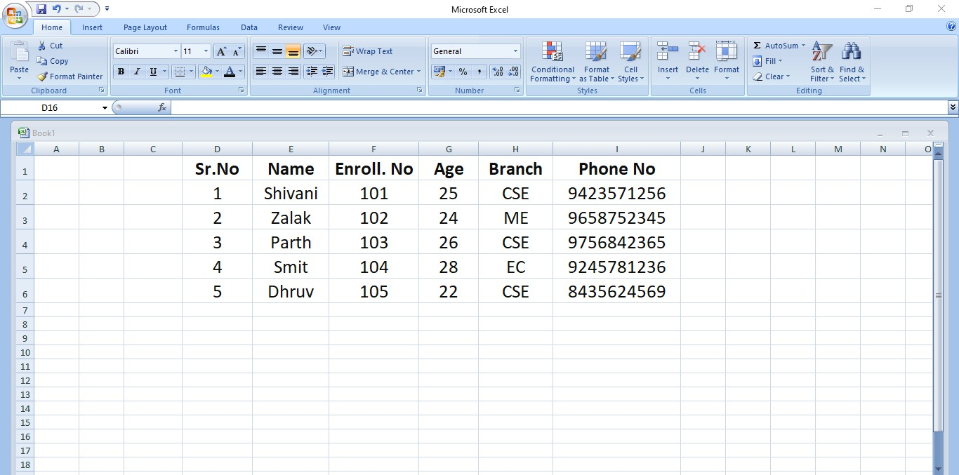

- Employee Details using MS Excel:

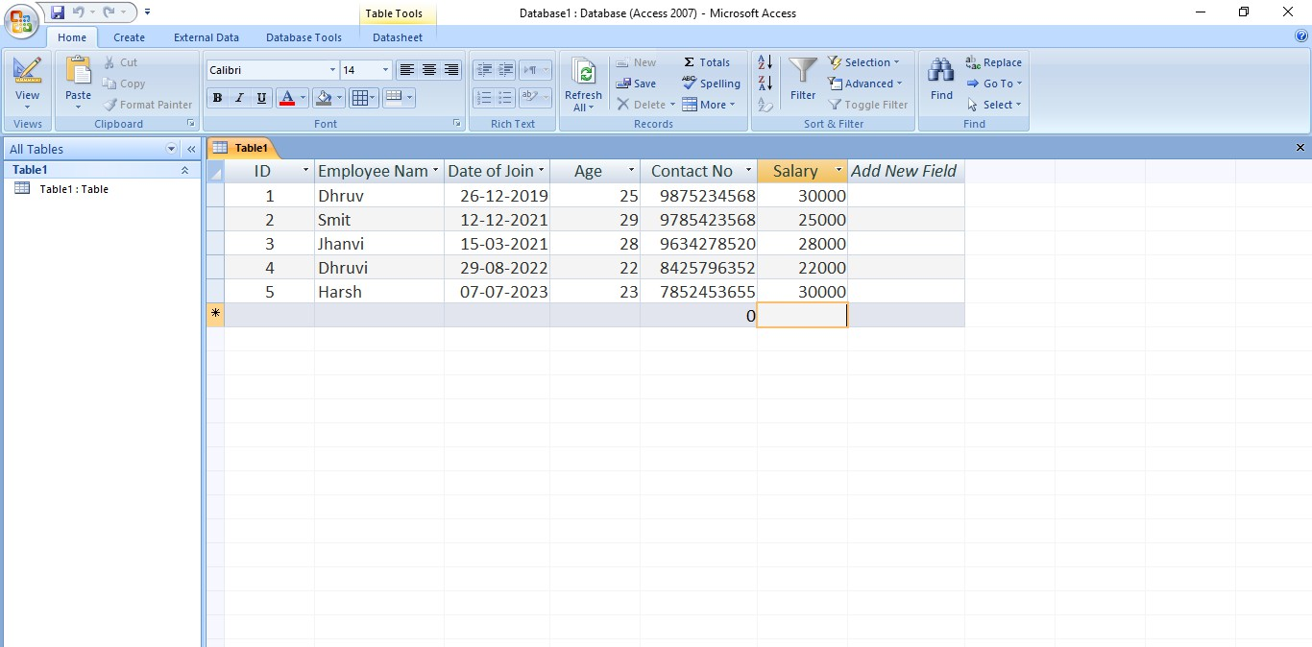

- Facebook using Excel:

